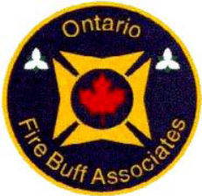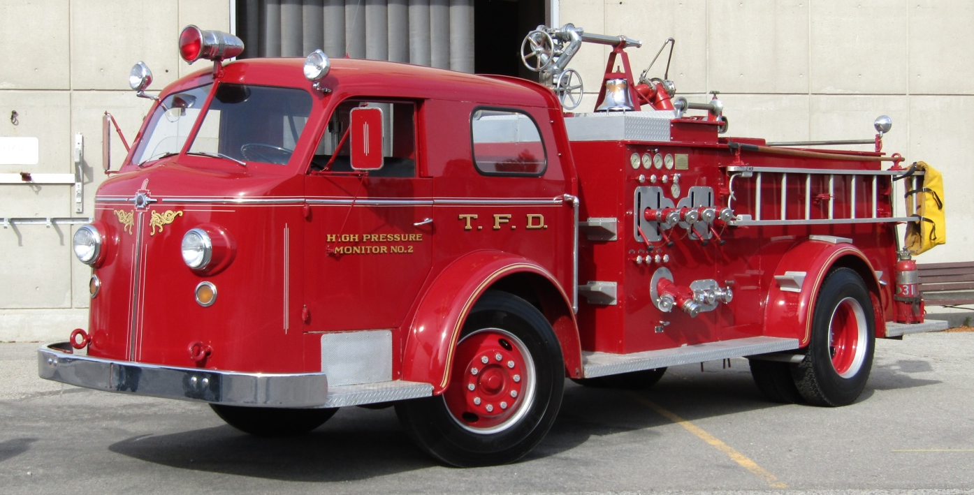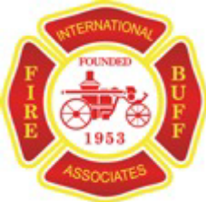

The Ontario Fire Buff Associates
28th Annual

FIRE SERVICE

COLLECTIBLES

SHOW & SALE

Toronto Fire Services – Training Academy
(895 Eastern Ave. at Knox Ave., M4L 1A2)

Saturday, November 2, 2019 from 08:30 to 12:00

FREE ADMISSION – PUBLIC WELCOME

If you are looking to add to your firematic collection or purchase a Christmas gift for that special someone, or you have anything of a firematic nature that you wish to sell, such as books, photos or slides, toys, diecast or plastic models, patches, pins, or other fire memorabilia, please join us.

Sales tables are readily available at no charge. For further information, please call
Robert Herscovitch at (416) 497-8968.

Directions to the Toronto Fire Academy

From the East: West on Kingston Rd., continue onto Eastern Ave. and turn left on Knox Ave. The academy is on the right. The entrance to show and parking is at the rear of the building. Turn right at the first entrance.
From the West: Take the Gardiner Expressway to the end onto Lakeshore Blvd. and continue east to Leslie St. Turn left and go north one block to Eastern Ave. Turn right on Eastern and go east one long block to Knox Ave. and turn right.
From the North: Go South on the Don Valley Parkway to Lakeshore Blvd. Turn left onto Lakeshore Blvd. and follow above directions to Leslie St and Eastern Ave.

